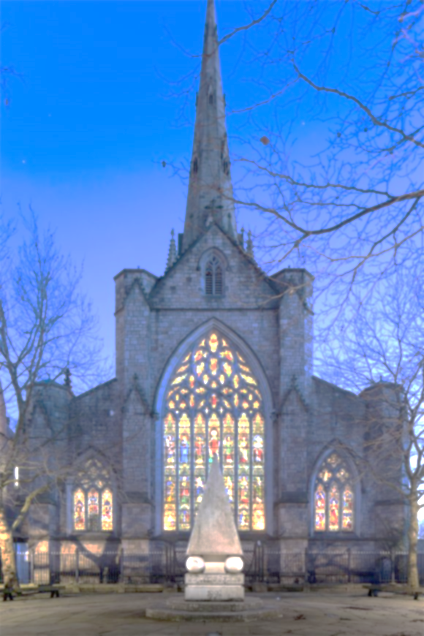
THE PARISH OF OUR LADY OF MOUNT CARMEL AND ST JOSEPH

MASS OFFERING(S)

INTENTION(S) …..……………………………………….……….……….

NUMBER OF MASSES ……...… OFFERING ……………….……

DONOR …………………….…… PHONE ……………...…………

For online Mass Offering(s), please make payment detailed below:

NAME OF PAYEE St John’s Cathedral, Salford A/C NO 83715442
BANK Barclays Bank PLC SORT CODE 20-55-58
Please use donor’s name and amount as above for our reference e.g. JohnSmith123

SPECIAL INSTRUCTIONS (IF ANY) ………………………………………..…………………………………………………………………………………………………………………………………………………………………………………………..……………………………

Email to

cathedral.admin@dioceseofsalford.org.uk
Charity number 250037

