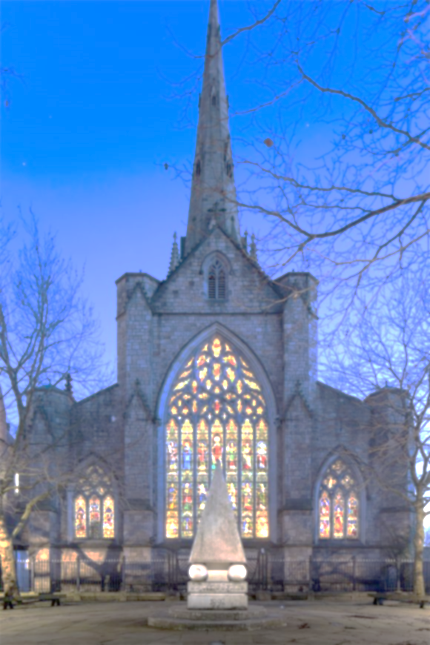
THE PARISH OF OUR LADY OF MOUNT CARMEL AND ST JOSEPH

MASS OFFERING(S)

INTENTION(S) …..……………………………………….……….…………………………………………………………..…………………………………..………………….
NUMBER OF MASSES ……...… OFFERING £ ……………….……
DONOR …………………………………………………..…….……
PHONE ……………...……………………………………….………

For online Mass Offering(s), please make payment detailed below:

NAME OF PAYEE St John’s the Evangelist A/C NO 10921211
BANK Barclays Bank PLC SORT CODE 20-55-34
Please use donor’s name and amount as above for our reference e.g., JohnSmith123

Email to

cathedral.finance@dioceseofsalford.org.uk
Charity number 250037

