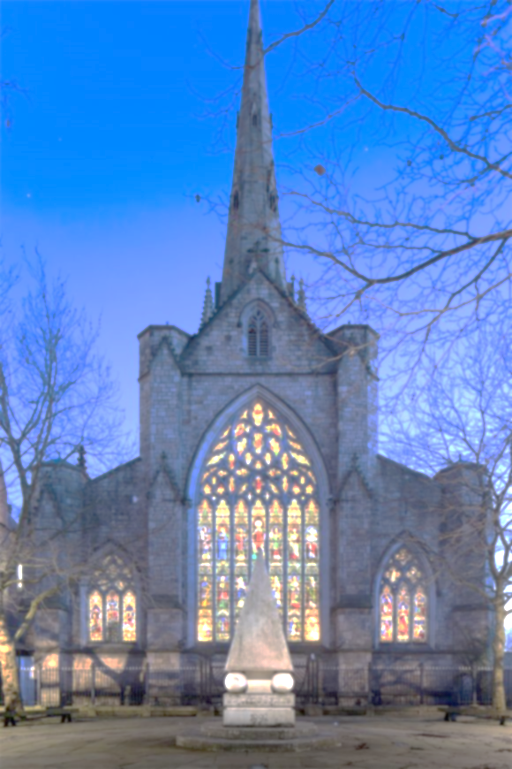
THE PARISH OF OUR LADY OF MOUNT CARMEL AND ST JOSEPH
MASS OFFERING(S)
INTENTION(S) …..…………………….….…………………….…………………………….
NUMBER OF MASSES ……...… OFFERING £ ……………….……
DONOR …………………………………………………..…….……
PHONE ……………...……………………………………….………
For online Mass Offering(s), please make payment detailed below:
NAME OF PAYEE TSDT Our Lady of Mount Carmel and St Joseph
BANK Barclays Bank PLC
A/C NO 10921211 SORT CODE 20-55-34
For our reference, please quote MassInt+donor’s name e.g., MassIntJohnSmith
☐ Tick and complete details below if you would like to Gift Aid this donation.
Title ……...… Full Name ……………..……………………………………….….....…
Home Address ……………..…………………….………………..………………........…
……………..……………………………………….……...… Postcode ……...............…
Date …………………………………. Signature ……..…..….....................................................…
I want to Gift Aid this personal donation and any donations I make in the future or have made in the past 4 years, to this charity. I am a UK taxpayer and understand that if I pay less Income Tax and/or Capital Gains Tax than the amount of Gift Aid claimed on all of my donations in that relevant tax year it is my responsibility to pay any difference. This charity will claim 25p on every £1 donated.

☐ Would you be happy to receive updates from Salford Cathedral?

Email to finance@salfordcathedral.co.uk
Registered Charity No. 250037

